**CONTENT**

|  |  |  |
| --- | --- | --- |
| **S.No.** | **CONTENT** | **PAGE No.** |
| 1. | Abstract | 2 |
| 2. | Project Overview | 3 |
| 3. | System Design | 4 |
| 4. | Input Design | 8 |
| 5. | Output Design | 8 |
| 6. | Menu Level Description | 9 |
| 7. | Process Specification | 10 |
| 8. | Screen Layouts | 11 |
| 9. | Conclusion | 13 |
| 10. | Bibliography | 14 |

**ABSTRACT**

# The Online Home Rental System is a comprehensive, web-based application designed to simplify and automate the property rental process for tenants, landlords, and administrators. This system replaces traditional manual methods with a centralized digital platform, enabling users to easily browse available properties, apply for rentals, and track their application statuses in real time.

# Tenants can submit their personal details, select preferred properties, and upload necessary documents, while landlords can list their properties, manage applications, and monitor tenant information. Administrators have access to a centralized dashboard to oversee property listings, user registrations, and rental statuses.

# Built using modern web technologies such as HTML, CSS, and JavaScript, the system ensures responsiveness and cross-platform compatibility, making it accessible across various devices. Its intuitive design ensures a seamless user experience for both tenants and landlords, promoting efficiency and ease of use. The system enhances operational transparency by allowing real-time updates on property availability and application statuses, reducing the manual effort involved in property management and rental processing.

# In addition to streamlining basic rental operations, the system is scalable, with potential future features such as payment gateway integration, automated rental reminders, and analytics for landlords and administrators. Overall, the Online Home Rental System optimizes the rental process, providing a more efficient, user-friendly, and transparent platform for managing rental properties.

# INTRODUCTION

### PROJECT OVERVIEW

## The Online Home Rental System is an advanced, user-friendly web application designed to streamline and automate the process of property rentals for tenants, landlords, and administrators. This system replaces outdated paper-based processes with a centralized, digital platform that enhances the efficiency, transparency, and accessibility of rental management for all stakeholders.

## The system allows tenants to easily browse available rental properties, submit rental applications, and track the status of their requests in real-time. Key features include a user-friendly application form where tenants can input their personal details, select preferred properties, and upload required documents. The system performs validations to ensure completeness and accuracy before submission.

## Once the application is submitted, tenants can view the status of their applications, receive notifications about property availability, and monitor updates from landlords. On the administrator side, the system provides tools for managing property listings, overseeing tenant applications, and tracking property occupancy status, ensuring a smooth and organized management process.

## Built with modern web technologies such as HTML, CSS, and JavaScript, the Online Home Rental System is designed to be responsive, lightweight, and cross-platform compatible, providing a seamless experience across various devices. The intuitive interface enhances user engagement, making it easy for both tenants and landlords to navigate and interact with the system.

## The workflow of the system begins with tenant registration and property browsing, followed by property application submissions and approval processes. For landlords, the system offers a centralized control panel for managing property details, reviewing applications, and tracking rental performance. For administrators, the system improves efficiency by automating administrative tasks such as managing users, reviewing applications, and generating reports.

## By digitizing the property rental process, the Online Home Rental System significantly reduces administrative workload, increases operational efficiency, and enhances the overall rental experience for tenants, landlords, and administrators. It modernizes the home rental process, ensuring a smooth, transparent, and hassle-free experience for all parties involved.

## 2. SYSTEM DESIGN

### 2.1 INTRODUCTION

System design is the process of defining the architecture, components, modules, interfaces, and data structures that collectively fulfill the specified requirements of a software system. It represents the transition from understanding what a system needs to do (as identified in system analysis) to figuring out how to achieve those requirements in a structured and efficient manner. While system analysis answers the “what is” question, system design addresses the “how to” aspect of building or improving a system.

This phase plays a critical role in shaping the success of the project. It involves not only outlining technical solutions but also ensuring that these solutions align with the operational and strategic goals of the organization. System design takes the recommendations from the feasibility study and converts them into a comprehensive blueprint for development, laying the groundwork for the implementation phase.

Before diving into system design, careful planning is essential. It is important to conduct a thorough analysis of the existing system—understanding its limitations, inefficiencies, and pain points—to identify how the new or upgraded system can bring about measurable improvements. This involves evaluating how the integration of computing technologies can enhance overall performance, reduce manual effort, and streamline workflows.

The significance of system design lies in its impact on quality. Design is where the foundation for high-quality software is built. A well-crafted design not only meets user requirements but also ensures maintainability, scalability, security, and efficiency of the system. It acts as a communication bridge between the end-users and the developers by transforming user-oriented documentation into technical specifications that can be interpreted and implemented by programmers, database administrators, and system architects.

Moreover, system design is both a technical and creative endeavor. It demands a blend of analytical thinking, problem-solving, and innovation to architect a solution that is technically feasible, economically viable, and user-friendly. It also includes considering user interfaces, data flows, control logic, and hardware-software integration, all of which contribute to a system that is robust, adaptable, and efficient in meeting its intended purpose.

In summary, system design is not just a step in the development cycle—it is the foundation of a successful and sustainable software product. A strong design ensures that the final system is reliable, efficient, and tailored to meet user expectations and institutional objectives.

### 2.2 INPUT DESIGN

### Visitor (User):

### Visitor Form:

### Name: Name of the visitor (text input).

### Phone Number: Visitor’s phone number (numeric input, 10 digits).

### Email: Visitor’s email address (email input).

### Status: Whether the visitor is a "Family" or "Bachelor" (dropdown options).

### Validation:

### All fields are mandatory.

### Phone number must be exactly 10 digits.

### Email must follow a valid email format.

### Administrator (Property Manager):

### Property Listing Form:

### Property Title: Title of the property (text input).

### Price: Rent price for the property (numeric input).

### Location: The location of the property (text input).

### Furnishing: Furnishing type (dropdown: Semi-Furnished, Fully Furnished).

### Carpet Area: Size of the carpet area in square feet (numeric input).

### Contact Number: Property owner’s contact number (numeric input).

### Email: Property owner’s email address (email input).

### Validation:

### All fields are required.

### Price and carpet area must be numeric.

### Contact number must be exactly 10 digits.

### Email must follow a valid format.

### 2.3 OUTPUT DESIGN

### User Outputs (Visitor):

### Application Submission Confirmation:

### Upon successful form submission, a popup message appears: “Visitor registration submitted successfully.”

### The user is redirected to a confirmation page or stays on the dashboard displaying the current visitor details.

### Error Feedback:

### If required fields are missing or invalid:

### Error messages are shown next to specific fields (e.g., phone number format invalid).

### Form submission is prevented until corrections are made.

### Administrator Outputs (Property Manager):

### Property Listing Confirmation:

### Upon successful property submission, a popup message appears: "Property listing submitted successfully."

### The user is redirected to the property dashboard with updated property listings.

### Property List View:

### Displays a list of properties available for rent with the following details:

### Property Title

### Price

### Location

### Furnishing

### Carpet Area

### Contact Number

### Email

### Error Feedback:

### If there are missing or invalid fields, error messages are displayed for the admin to correct them before submission.

## 3. SYSTEM DEVELOPMENT

### 3.1 MENU LEVEL DESCRIPTION

###### 1. Login Menu:

###### Homepage:

###### The main landing page for users (tenants, landlords, and administrators) to enter their login credentials.

###### Fields: Username and Password.

###### Authentication Result:

###### On successful login, the user is redirected to the appropriate dashboard based on their role (Tenant, Landlord, or Admin).

###### On login failure, an error popup is displayed indicating incorrect credentials.

###### 2. Tenant Menu:

###### Tenant Dashboard:

###### Displays a list of available rental properties.

###### Each property entry includes:

###### Property title

###### Location

###### Rent price

###### Furnishing details

###### Carpet area

###### Apply button (for the tenant to apply for the rental).

###### Application Form:

###### Allows tenants to apply for a rental property.

###### Fields include:

###### Name

###### Email

###### Phone Number

###### Property Name (selected from available properties)

###### Reason for application

###### Includes a Submit Application button to complete the application.

###### Form Validation ensures all fields are filled correctly.

###### Tenant Output:

###### Application Submission Confirmation:

###### Popup: "Application submitted successfully."

###### The user is redirected to a confirmation page or remains on the dashboard, displaying submitted applications.

###### Application Status:

###### After the admin review, the status of the application is displayed as:

###### Pending

###### Approved

###### Rejected

###### Error Feedback:

###### If required fields are missing or invalid, error messages are shown next to specific fields.

###### Form submission is prevented until corrections are made.

###### 3. Landlord Menu:

###### Landlord Dashboard:

###### Displays a list of properties owned by the landlord.

###### Each property entry includes:

###### Property title

###### Location

###### Rent price

###### Current status (rented or available)

###### Property Management:

###### Allows landlords to add, update, or remove their rental properties.

###### Fields include:

###### Property title

###### Location

###### Rent price

###### Furnishing status

###### Carpet area

###### Buttons: Create Property / Update Property / Delete Property.

###### Landlord Output:

###### Property Management Dashboard:

###### List of properties with the option to add, edit, or delete property.

###### Error Feedback:

###### Error messages displayed for missing information or invalid data.

###### 4. Admin Menu:

###### Admin Dashboard:

###### Displays an overview of the system with metrics such as:

###### Total properties listed

###### Total tenants

###### Total landlords

###### Property Management:

###### Displays a list of all rental properties in the system.

###### Each property entry includes:

###### Property title

###### Landlord name

###### Rent price

###### Property status (available/rented)

###### User Management:

###### Allows the admin to manage tenant and landlord profiles.

###### Actions include:

###### Add new user

###### Edit user details

###### Delete user profile

###### Form Fields: Name, Email, Role (Tenant/Landlord), Password.

###### Rental Application Management:

###### Allows the admin to view and manage tenant applications for rental properties.

###### Each application can be reviewed and modified:

###### View all tenants who have applied for a property.

###### Approve or reject a tenant's application.

###### Notify tenants of their application status.

###### Admin Output:

###### Property Management Overview:

###### Displays list of all properties with options to edit or remove.

###### User Management Overview:

###### Provides actions for managing tenant and landlord accounts.

###### Rental Application Dashboard:

###### Displays a list of all tenant applications and allows admins to approve or reject applications.

### 3.2 PROCESS SPECIFICATION

1. **Tenant Registration Submission:**

**Step1:**  
 • The tenant accesses the Tenant Registration Form and enters all required details:

* **Full Name**: Tenant's name (text input).
* **Email**: Tenant's email address (email input).
* **Phone Number**: 10-digit contact number (numeric input).
* **Preferred Location**: Area or neighborhood where the tenant is looking for a rental property (text input).
* **Budget**: Tenant’s budget for rent (numeric input).
* **Move-in Date**: Date picker to select the preferred move-in date.
* **Gender**: Dropdown to select gender.
* **Age**: Numeric input for tenant’s age.

**Step2:**  
• The system performs validation to ensure:

* All required fields are completed.
* Email follows a valid email format.
* Phone number must be exactly 10 digits.
* Budget and move-in date are logical (positive values and within an acceptable range).
* The tenant’s age is validated according to rental property requirements.

**Step3:**  
• Upon successful validation, the form data is submitted, and a success message is displayed:

* **Success Popup**: "Tenant registration submitted successfully."

**2. Property Listing Submission (Landlord View):**

**Step1:**  
• The landlord accesses the Property Listing Form and enters all required property details:

* **Property Title**: Name or title of the property (text input).
* **Location**: Address or location of the property (text input).
* **Rent Price**: Rent price of the property (numeric input).
* **Furnishing Status**: Type of furnishing (e.g., Furnished, Semi-furnished, Unfurnished) (dropdown).
* **Carpet Area**: Size of the property in square feet (numeric input).
* **Property Type**: Type of property (e.g., 1 BHK, 2 BHK, Apartment) (dropdown).
* **Available From**: The date when the property is available for rent (date picker).

**Step2:**  
• The system performs validation to ensure:

* All required fields are completed.
* Rent price and carpet area are positive numbers.
* The property type is selected from the available options.
* The available from date is valid and after the current date.

**Step3:**  
• Upon successful validation, the form data is submitted, and the property is listed for potential tenants to view.

* **Success Popup**: "Property listed successfully."

**3. Property Application Submission (Tenant View):**

**Step1:**  
• The tenant accesses available properties via the **Tenant Dashboard** and selects a property to apply for.

* Tenant can view property details such as rent, location, property type, and availability.

**Step2:**  
• The tenant submits an **Application for Property** form with the following fields:

* **Tenant Name**: Pre-filled from registration details (text input).
* **Email**: Pre-filled (email input).
* **Phone Number**: Pre-filled (numeric input).
* **Property Title**: Automatically selected based on the property the tenant is applying for (dropdown).
* **Reason for Application**: A short justification for why the tenant wants to rent the property (text area input).
* **Desired Move-in Date**: A date picker to select the move-in date.

**Step3:**  
• The system validates the application:

* All required fields must be completed.
* A valid email and phone number format must be used.
* The move-in date must be logical (not before the property’s available date).

**Step4:**  
• Upon successful validation, the application is submitted and stored.

* **Success Popup**: "Application submitted successfully."
* The tenant can track the application status via the dashboard.

**4. Application Review and Status Update (Admin View):**

**Step1:**  
• The administrator accesses the **Admin Dashboard** to view and manage all property applications.

**Step2:**  
• The system retrieves and displays all applications in a list format, including:

* Tenant Name
* Property Title
* Application Status (Pending/Approved/Rejected)
* Date of application
* Move-in date requested

**Step3:**  
• The administrator reviews each application and updates the application status.

* Approve or Reject the application.
* Update the status and notify the tenant via email or dashboard alert.

**Step4:**  
• Upon updating the status, the tenant is notified via email or dashboard alert regarding their application status (Approved/Rejected).

**5. Access Control:**

**Step1:**  
• Only authenticated users (tenants, landlords, and administrators) can access the system.

* Tenants can browse properties, submit applications, and track application status.
* Landlords can list, edit, and manage their properties.
* Administrators can manage applications, users, and properties.

**Step2:**  
• Unauthorized users are restricted from accessing the system or performing any actions.

**6. System Maintenance and Scalability:**

**Step1:**  
• The system supports future enhancements such as:

* Adding new property categories (e.g., commercial spaces, hostels).
* Modifying the property application process for more customization.
* Implementing an integrated payment gateway for online rent payments.

**Step2:**  
• Future features could include:

* Real-time notifications for tenants about property availability or rent updates.
* Mobile application support for tenants and landlords to manage their accounts on-the-go.
* Analytics and reporting features for administrators to track property demand, applications, and performance.
* Integration with third-party platforms for background verification of tenants and landlords.

**4. SYSTEM TESTING**

**4.1 SCRREEN LAYOUTS**

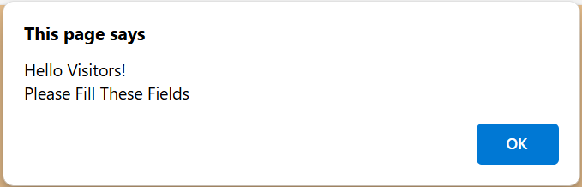

Visitor Form Welcome Message

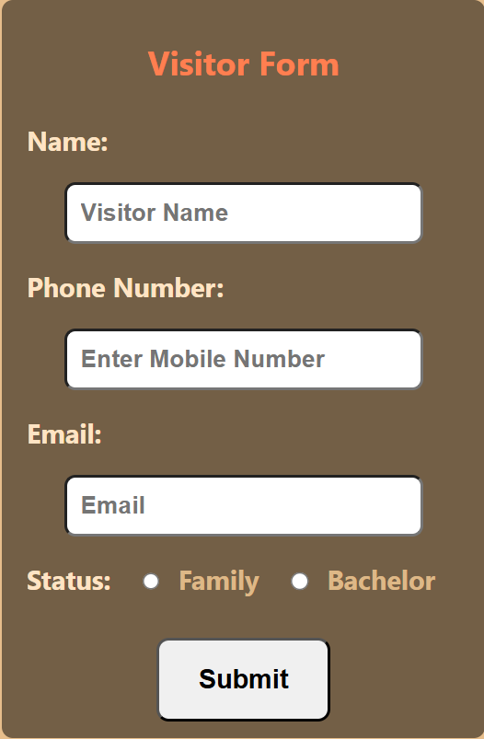

**Visitor Form**

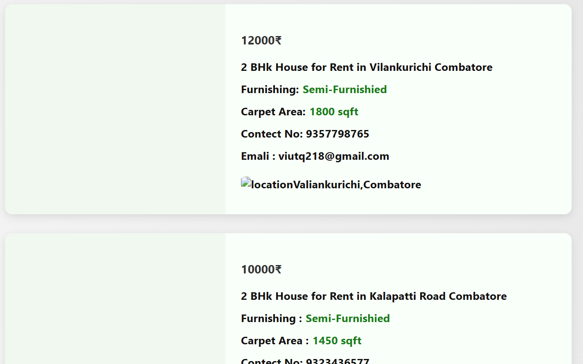

Rental Property Listings

## 5. CONCLUSION

## The Online Home Rental System is a powerful, user-friendly platform designed to simplify and automate the process of property rental management for tenants, landlords, and administrators. By replacing outdated manual systems, this system provides a seamless platform for tenants to browse available rental properties, apply for rentals, and track their application statuses, while allowing landlords to manage their listings, approve applications, and monitor occupancy with ease. Administrators can centrally manage both user profiles and property data, ensuring efficiency and transparency across the entire rental process.

## With an intuitive design, the system offers a hassle-free experience for tenants, landlords, and administrators alike. Tenants can easily find properties that suit their needs, submit applications, and stay informed about the status of their requests, while landlords can manage property listings, applications, and tenant details in an organized manner. The role-based access control ensures that each user can only access the features relevant to their role, maintaining both security and efficiency.

## Developed using modern technologies like HTML, CSS, and JavaScript, the system ensures responsiveness and cross-platform compatibility, making it accessible across various devices. Its modular architecture allows for future scalability, enabling the integration of additional features such as automated rent payments, maintenance request management, and lease renewal tracking, making it a flexible solution for property management.

## By automating key processes such as property listing, application management, and tenant communications, the Online Home Rental System significantly reduces administrative effort, increases operational efficiency, and enhances the overall rental experience for both tenants and landlords. The system’s focus on real-time updates and seamless communication creates a transparent and efficient rental process, ensuring that all stakeholders—tenants, landlords, and administrators—have a smooth and hassle-free experience.

## 6. BIBLIOGRAPHY

1. OpenAI: "GPT-3: Language Models for Text Generation." https://[www.openai.com](http://www.openai.com/)
2. GeeksforGeeks: "Computer Science Portal." [https://www.geeksforgeeks.org](https://www.geeksforgeeks.org/)
3. YouTube: “Various Tutorials and Educational Content." https://[www.youtube.com](http://www.youtube.com/)